October 2022 Newsletter
Smear Study, High calls for Face to Face appointments & phone myth, New Practice Manager, GP, Skin Cancer triage & Message in a Bottle

Fast Facts
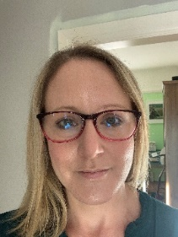
Cervical Screening Nationally has seen a decline in testing numbers. A study has been set up to look at ways this might be improved upon with self-screening. HPValidate is aimed at increasing the access to cervical screening. The Orchard Surgery has been selected to take part and Dr Aston is leading on this topic. She needs a total of 200 women to take part. A big thank you to the women who have joined in the study so far, your participation will help women in the future to benefit from more convenient cervical screening. A letter outlining the process will be sent out with all screening invitations. Please talk to your nurse when attending for the smear test about taking part in this important study.

Demand for appointments with the Orchard Surgery clinicians remains high, despite the usuall summer decline in requests. In line with many other surgeries here at the Orchard Surgery we offer a range of access routes to help spread the workload across all the clinical personnel. Do take advantage of this variety when contacting the surgery. Something like three telephone appointments can be completed in comparison to one face to face contact.
In a typical week the Orchard Surgery gets an average of 3000 calls. With an average of 350 GP appointments each week this inevitably means most patients have to wait a while for face to face consultations.
If you have to wait, do explore alternative means of accessing the Surgeries clinicians when talking with reception staff.

The multiple phone myth. Patients have reported that often they will use the house phone and a mobile phone to try to connect with the surgery quicker. In these highly computerised days this is just not a viable option and is just an extra burden on the switchboard and other waiting patients. All calls are queued by the time code they are logged. So please don’t try this.
People Peeps: New GP Update Dr David Tasack
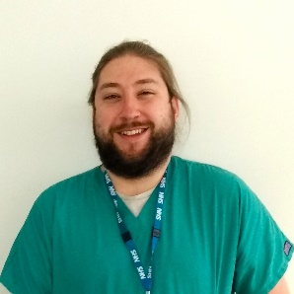
I'm Dave, one of the new salaried GPs at the Orchard.

I completed my final year of GP registrar training here and was very happy to be kept on as part of the team! I went to school locally (Wirral Grammar) then studied my first degree at Kings College London, during which I received a First Class Honours in Physiology. I came back to my native Merseyside to study Graduate Medicine at the University of Liverpool (graduated in 2017).

I am passionate about education in all aspects, and I currently supervise medical students from the University of Liverpool who undergo clinical placements here throughout the year.

I am currently working as part of a fellowship programme, working more within medical education, and also looking into chronic pain within the local population.

Outside of work, I live with my girlfriend and we have recently adopted a lovely rescue dog who takes up most of our time!

If not seen at dog socials or running after our dog, I'll often be enjoying a range of nerdy hobbies!

Our health in focus
Skin cancer affects 156,000 people every year, that’s about 430 new cases diagnosed every day. Here at the Orchard Surgery we have joined the Tele-dermatology and e-referral system. Dr Cooke has an interest in dermatology and is leading on this initiative.
Patients can be assessed using a dermoscope to look inside the outer skin layers. The high definition photographs are sent via a secure NHS internet connection to a specialist for review. This approach will speed up the diagnosis and improve the two-week referral rate. Making it quicker for patients to be reassured about their skin lesion.

Wirral Lions organisation have produced a Message in a Bottle resource for patients who may need their clinical information to hand if called upon by paramedic staff in an emergency at their home. For more information email Wirrallions@yahoo.co.uk. Or pick up a bottle from reception.
Message in a Bottle is supported by; Ambulance Service, Police, Fire and Rescue Services, Emergency Doctors and the NHS.

Footnote: Do recycle this paper copy
For more information go the Orchard website on https://theorchardsurgery.nhs.uk

