Welcome Pack for New Patients
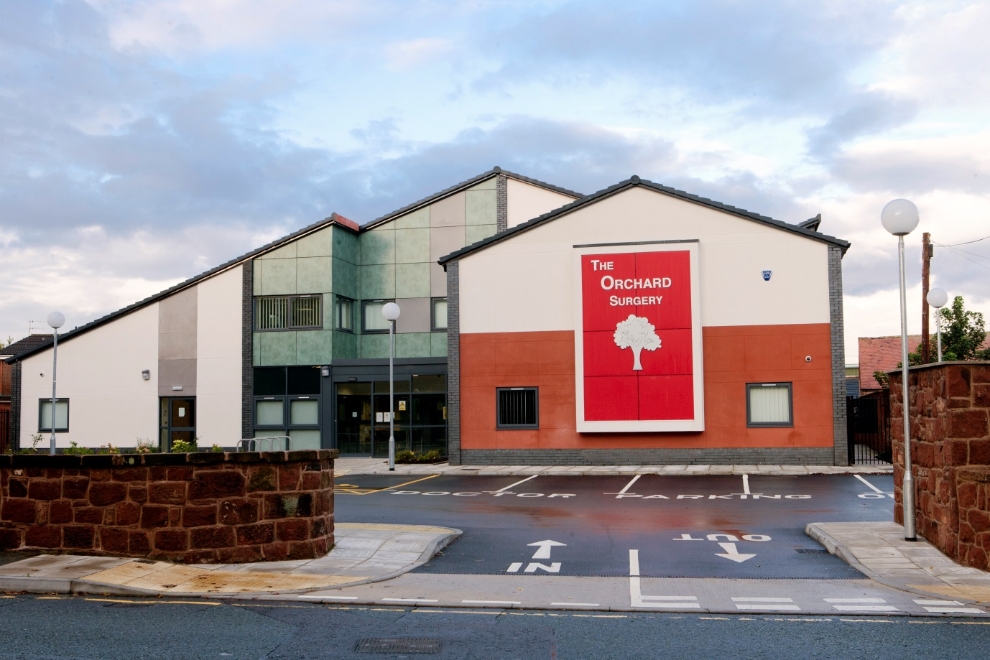

The Orchard Surgery  Bromborough Village Road  Bromborough  Wirral  CH62 7EU  T: 0151 334 2084  F: 0151 343 9437  E: wiccg.orchardteam@nhs.net  W: www.theorchardsurgery.nhs.uk | Opening Times Closing Times  Monday 7.30am 6.30pm  Tuesday 7.30am 6.30pm  Wednesday 8.30am 8pm  Thursday 8.30am 6.30pm  Friday 8.30am 7pm  Saturday Closed  Sunday Closed

Welcome to the Orchard Surgery! We hope this information helps you get to know your new practice and what we offer to our patients. As a practice we work hard to provide high quality services but we also have an expectation that our patients will work with us to improve their health and take action on the advice given. We believe that good relationships are critical to success so we ask that you respect our team members as we respect you. Together we can achieve happier, healthier lives!
If you have any questions about anything contained within this pack, please feel free to contact our friendly reception team who would be happy to help.

Premises
The new building opened in September 2011, providing modern facilities and a bright and welcoming space for our patients. The building is 2 storey, with all direct patient services situated on the ground floor.

Disabled Access
The premises comply with disability legislation and, as such, are fully accessible to people with disabilities. There are 2 designated parking bays close to the entrance of the building.

Parking
There is a small car park at the front of the building, and there is street parking to be found within a short distance, should the car park on occasion be busy.

Public Transport
The practice is approximately a 15 minute walk away from Bromborough Rake Train Station

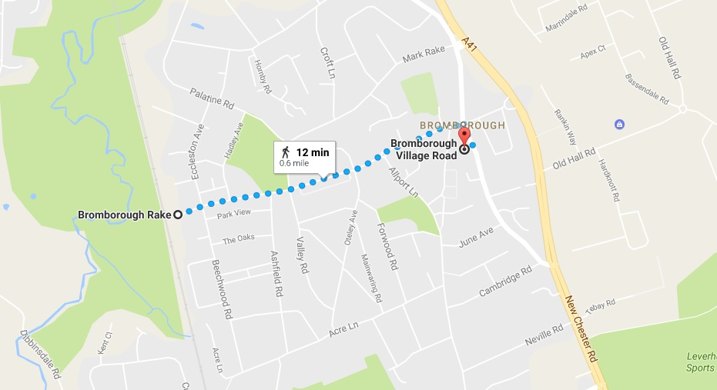

Bus Routes
There is a bus stop opposite the practice on Bromborough Village Road, bus routes are 41, 41A, 42 and 358.

THE PRACTICE TEAM

Clinical Team:

Dr Anne P Tomlinson (Partner)
MB BCh Wales 1977 MRCGP DCH DRCOG

Dr Bryan A Conlan (Partner)
MB ChB Dundee 1996 MRCGP DFSRH

Dr Thomas D Wyatt (Partner)
MB ChB Liverpool 2002 MRCGP

Dr Ellen Aston
MB Chb Birmingham 2004 MRCGP DRCOG DFSRH

Dr Maria Jones
MB ChB 2002 Sheffield MRCGP DRCOG DFSRH

Nurse Clinician—Sister Ursula Booth— SRN MSc BA Hons
Sister Booth works alongside the doctors, holding regular surgery sessions providing acute “first contact” medical care to our patients.

Sister Helen Hurst RGN
Sister Stacy Davies RGN
Sister Jenny Barbour RGN
Our practice nurses run our chronic disease management clinics and they are available for general nursing services including cervical smears, child vaccinations and travel advice.

Louise Feightman HCA, Ashley Layfield HCA and Linda Evans HCA
Our HCAs are available for general nursing duties such as blood pressure checks, general health checks, ear syringing, ECGs, anticoagulation etc.

Admin Team:

Karen Livesey
Practice Business Manager

Mary Higham
Deputy Practice Manager

Sam Jones
Medical Secretary

Annette Owen and Vikki O’Neill
Prescriptions Administrators

Sarah Roberts
Administrator

Reception Team
Gill Cooper
Sue Freeman
Sandra Wilde
Katie Buckingham
Lynda Byrom

When We Are Closed

If you require a doctor at any time always phone 0151 334 2084 in the first instance. If the surgery is closed, you will be advised of this by the answering machine message and told to ring 111.

Walk-In Centres
There are 3 Walk-In Centres locally which you can visit on any day of the week without an appointment. Consultations are with experienced nurses and they are able to treat minor injuries and illnesses e.g. strains and sprains, coughs, colds and flu like symptoms etc.

Victoria Central Walk-in-Centre, Mill Lane, Wallasey CH44 5UF.
Opening Times: Monday – Sunday (including bank holidays) 8am – 10pm (x-ray facilities open at 8.30am)

Eastham Walk-in-Centre, Eastham Rake, Eastham CH62 9AN.
Opening Times: Monday – Friday 2pm – 10pm (excluding bank holidays)
Weekends and bank holidays – 9am – 5pm

All Day Health Centre, Arrowe Park Hospital, Arrowe Park Road, Upton CH49 5PE.
Opening Times: Monday – Sunday 8am – 10pm (including bank holidays)

Emergency
Call 999 in an emergency. Chest pains and / or shortness of breath constitute an emergency.

APPOINTMENTS

A full appointment system is employed but urgent cases will always be seen the same day. You can make an appointment by telephone or by using patient access (online services). Each consultation is allocated 10 minutes so please make the reception team aware if you have more than one concern you wish to discuss.

Please note we will do our best to accommodate your needs, both medically and in offering you suitable appointments. An appointment that fits your schedule may not always be available with your preferred doctor.

If you are unable to attend for an appointment, please notify us (or ask someone to do it for you) as soon as possible, so that the appointment may be offered to someone else.

Telephone Consultations
Telephone consultations are available for the doctors and nurse clinician. If you feel your problem could be dealt with over the telephone, or if you need advice, please ask the receptionist to book you a telephone consultation. The doctors will ring you when they have finished surgery.

Text Messaging
We offer a text reminder service. If you would like to be reminded about appointments in this way please give your mobile number in at reception.

Emergency appointments
Emergency appointments are given out on the day you need to be seen.

Home Visits
If possible please try to telephone reception before 11:00am if you require a home visit.
A doctor or nurse may phone you back as it may be that your problem can be dealt with by telephone advice, or that it would be more appropriate to send a nurse, or indeed arrange a hospital attendance.
House visits are only available for patients who are housebound because of illness or disability.
Please remember that several patients can be seen in the practice in the time that it takes to make one home visit. There are also better facilities for examining and treating patients at the surgery.

Medical Students
Students attend the practice as part of their training and will sit in on surgeries. You will be advised if there are students. If you do wish them to the present during your consultation please advise the reception staff.

CLINICS AND SERVICES

As well as general medical services we also offer the following services:

Asthma & Chronic Obstructive Airways Disease Management
These checks are designed to monitor and improve the care of your breathing problems, with advice on inhaler technique and medication

Cervical Smear Tests
These are usually performed by our Practice Nurses

Diabetic Management
Our Practice Nurses are trained in the specific needs of diabetic patients and offer regular advice and health assessment.

Minor Surgery
By arrangement with a doctor.

Coronary Heart Disease Management
Practice Nurses run this clinic for regular monitoring of those with established heart disease.

Maternity Care
Care during pregnancy and postnatal checks are organised in conjunction with the Community Midwifery team.

Childhood Immunisation
All routine vaccinations are done in our clinic, up to and including the pre-school booster. Appointments are arranged by child health.

Child Health Surveillance
Six week health checks are carried out on all babies. You will be invited to bring your baby to the surgery for this.

NHS Health Check
These are with our Healthcare Assistants, during which your blood pressure, urine, height and weight will be checked and any advice regarding diet, lifestyle (smoking , alcohol, exercise, for instance) will be given.

Hypertension
Regular blood pressure monitoring is organised for those patients on treatment for high blood pressure. Our nurses are also involved in screening patients to detect high blood pressure

Foreign Travel Advice & Vaccinations
Our Practice Nurses will give advice on the health aspects of travel, malaria prevention, and give, or advise on, any vaccinations necessary. You will be asked to complete a questionnaire to give the nurses as much information as possible ahead of your appointment.

Smoking Cessation
Appointments and a drop in service are offered from the Practice by ABL Wirral.

Women’s Clinic
This is run once a month by Dr Aston for advice and fitting of IUCD and coils.
PRESCRIPTIONS

Requests for repeat prescriptions should be put in the box provided using the tear off printed portion from your previous prescription or ordered online using patient access. Tick only the items you require.

Telephone requests are not accepted as mis-heard information can lead to dangerous mistakes.

Please allow 2 working days (weekdays) before collection after 4.00pm.It is patients’ responsibility to put their repeat request in plenty of time

TEST RESULTS

All specimens you have been asked to bring in for processing at the hospital laboratory are collected from the Practice daily, Monday to Friday. Please ensure that specimens for testing are handed into reception before 12 noon and the container is clearly marked with the patients’ name and date of birth.

Please call after 3:00pm to enquire about your test results as our reception staff will have more time to deal with your request at this time.

Note that the practice has a strict policy regarding confidentiality and data protection and we will only release test results to the person to whom they relate unless that person has given prior permission for the release of this data or they are not capable of understanding the results.

When you take your test you will be told how long it will be before the results are returned to the practice.
It is your responsibility to check your results and to make an appointment to discuss them with your doctor if you are advised to do so.

Blood Tests

For blood tests, patients will be given a form.
For routine and urgent blood tests a drop-in service will run Monday – Friday, 8:30am – 4:30pm at the following clinics:

- St Catherine’s Health Centre
- Victoria Central
- Eastham Clinic
- All Day Health Centre, Arrowe Park Hospital

Patients will be seen in order of arrival and waiting times will vary.

Patients requiring a Glucose Tolerance Test (GTT) can ring the Central Booking Service on 0151 514 2222 and request a time slot that suits their circumstances.

Requests for domiciliary (housebound) phlebotomy can be arranged by the practice.

X-Ray
X-rays usually take around 7 to 10 working days for the results to be sent to your surgery.

RESPECT

Zero Tolerance to Violence Policy
The NHS operate a zero tolerance policy with regard to violence and abuse and the practice has the right to remove violent patients from the list with immediate effect in order to safeguard practice staff, patients and other persons. Violence in this context includes actual or threatened physical violence or verbal abuse which leads to fear for a person’s safety. In this situation we will notify the patient in writing of their removal from the list and record in the patient’s medical records the fact of the removal and the circumstances leading to it.

CCTV
There are CCTV cameras situated in the reception area and around the perimeter of the building.

Complaints
We make every effort to give the best service possible to everyone who attends our practice.
However, we are aware that things can go wrong resulting in a patient feeling that they have a genuine cause for complaint. If this is so, we would wish for the matter to be settled as quickly, and as amicably, as possible.
To pursue a complaint please contact the practice manager or deputy practice manager, who will deal with your concerns appropriately. Further written information is available regarding the complaints procedure from reception.

PRIVATE FEES

Some of the work carried out in General Practice is classed as non NHS and may incur a charge, such as private sick notes, medicals such as HGV or forms and reports. A list of charges is displayed in the waiting room. You should be told in advance if there will be a charge for any administrative work done.

GET INVOLVED

Patient Panel
The Orchard Surgery has a panel of patients who meet monthly and work alongside the practice to review services. Information about the panel is displayed on a notice board in the waiting room.

